**Front-End UI/UX Mini Project**

**Project Submission Template**

**1. Title Page**

* **Project Title**: My Favorite City Blog – San Francisco
* **Submitted By**:

Naveen Tijo 2463039 naveentijo.btech.christuniversity.in

Chris Sunny Padayattil 2463016 chris.sunny@btech.christuniversity.in

Lana T 2463036 t.lana@btech.christuniversity.in

* **Course**: UI/UX Design Fundamentals
* **Instructor Name**: Dhiraj Alate
* **Institution**: Christ University
* **Date of Submission**: 13/8/2025

**2. Abstract**

This project is a multi-page blog website dedicated to San Francisco, created using HTML5 and CSS3. It highlights the city’s attractions, culture, gallery, and contact information. The objective was to design a visually appealing, responsive layout using semantic HTML and modern CSS techniques like Flexbox and Grid. The outcome is a fully functional, offline-ready static website optimized for desktop and mobile. This project helped in understanding web page structuring, responsive design principles, and the practical application of styling for user engagement.

**3. Objectives**

* Structure blog content using semantic HTML elements.
* Create a responsive design for desktop, tablet, and mobile devices.
* Implement CSS Flexbox for navigation and CSS Grid for gallery layouts.
* Use thematic colors inspired by San Francisco’s coastal and cultural aesthetics.
* Ensure visual appeal through typography pairing and hover effects.

**4. Scope of the Project**

•Front-end only: HTML5 and CSS3 (no JavaScript).

•Designed for offline and online viewing.

•Includes five pages: Home, Attractions, Culture, Gallery, and Contact.

•Optimized for performance and accessibility across devices.

**5. Tools & Technologies Used**

|  |  |
| --- | --- |
| Tool/Technology | Purpose |
| HTML5 | Markup and content structure |
| CSS3 | Styling and layout management |
| VS Code | Code editor |
| Chrome DevTools | Testing and debugging |

**6. HTML Structure Overview**

•Semantic tags: <header>, <nav>, <main>, <section>, <footer>, <figure>, <figcaption>.

•Navigation menu using <ul> with internal links to all pages.

•Gallery structured with CSS Grid.

•Contact form created with <form> elements (non-functional).

**7. CSS Styling Strategy**

• External stylesheet (style.css) with section-wise comments.

• Flexbox is used for navigation and featured posts.

• CSS Grid is used for a gallery layout.

• Media queries for mobile responsiveness.

• Hover effects on image cards for interactivity.

**8. Key Features**

|  |  |
| --- | --- |
| Feature | Description |
| Responsive Design | Adapts seamlessly to all screen sizes |
| Smooth Navigation | Fixed top nav with anchor links |
| Project Cards | Flex-based layout with hover effects |
| Contact Form (non-functional) | Placeholder layout for inputs and button |
| Accessible Fonts & Colors | High contrast and readable typography |

**9. Challenges Faced & Solutions**

|  |  |
| --- | --- |
| Challenge | Solution |
| Overlapping elements on small screens | Used media queries to stack elements |
| Difficulty aligning items using float | Shifted to Flexbox and Grid |
| Typography scaling issue | Used relative units (em/rem) instead of px |

**10. Outcome**

•Achieved a clean, content-focused design highlighting San Francisco’s charm.

•Improved practical skills in responsive layouts using HTML & CSS only.

•Developed the ability to organize multi-page website structures effectively.

**11. Future Enhancements**

• Add JavaScript for form validation and interactive content.

•Implement light/dark theme toggle.

•Integrate backend for contact form submissions.

•Add blog post pagination for scalability.

**12. Sample Code**

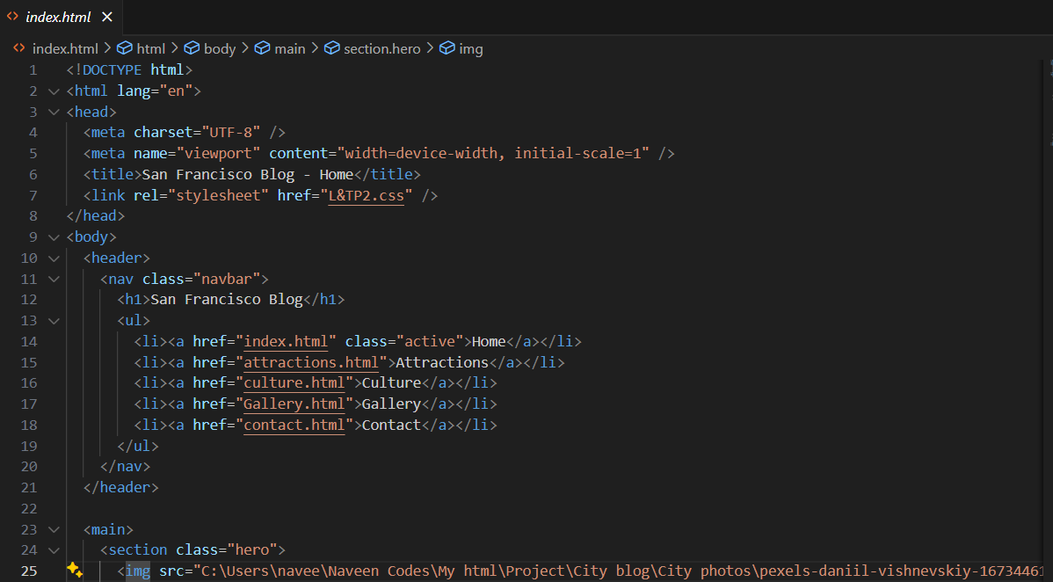

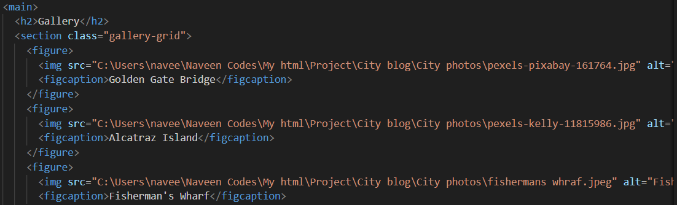

**13. Screenshots of Final Output**

**From Laptop**

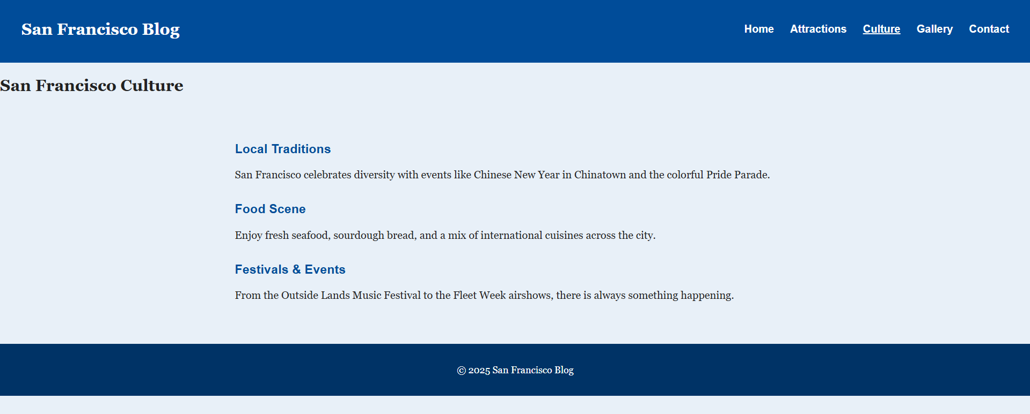

**From Phone**

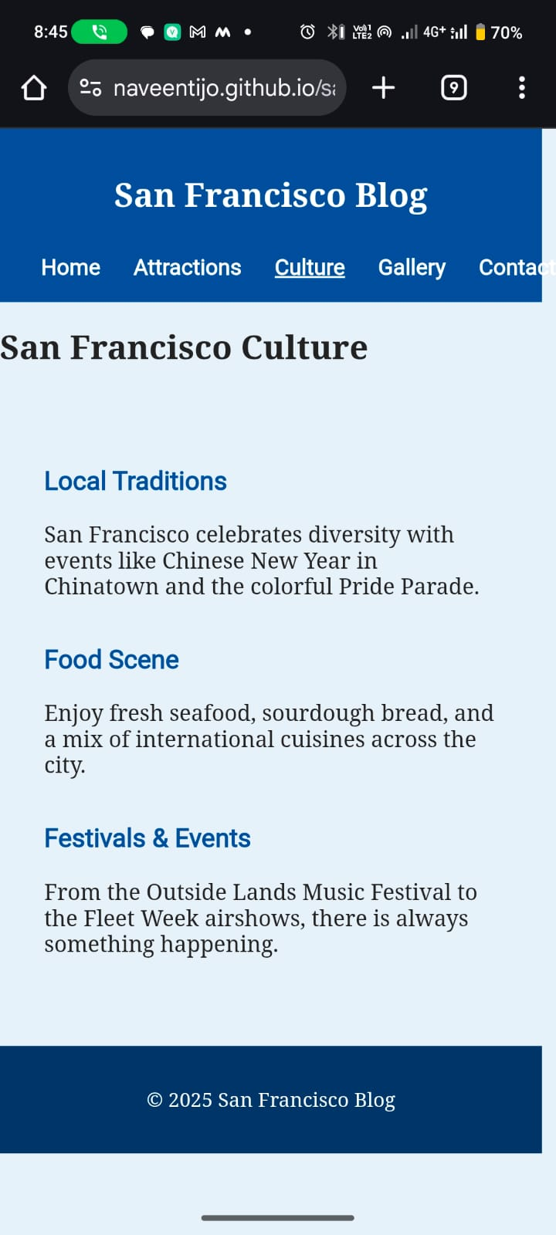

**11. Conclusion**

This project successfully demonstrates the development of a responsive, visually appealing blog website using only HTML and CSS. It improved understanding of semantic HTML, responsive design, CSS Grid, and Flexbox. Additionally, it enhanced skills in organizing multi-page projects and preparing them for hosting online.

**12. References**

•L&T LMS – <https://learn.lntedutech.com>

•W3Schools HTML & CSS Documentation – https://www.w3schools.com